**PPL Redshift Lab Instructions:**

We are going to leverage Redshift labs on Qwiklabs for the Immersion day. However, we will not be using the QwikLab environment but will create the lab environment in PPL’s AWS account. This lab guide provides instructions to set up the foundational environment provided by Qwiklabs. Once the foundational services are set up, the remainder of the instructions can be followed from the Qwiklab guide. Setting up the environment in PPL’s own account helps the participants to understand all the components that are required to set up a redshift cluster and the independence to experiment with various configurations outside of the lab instructions.

The instructions in this lab are divided in two parts. Part-1 focusses on setting up the environment for the Redshift cluster such as VPC, subnets, route tables, security groups and IAM roles. Since we are going to use a single account, the instructions in part-1 are required to be performed by only one user. The environment created will then be used by all the other participants to run their labs.

Part-2 focusses on instructions for individual participants.

**Part-1: To be done only once by a single user.**

1. We will use a cloud formation template to set up the environment. The cloud formation template can be found in the lab files folder. Following environment is set up by the template in the Ireland region (eu-west-1):
   * VPC (CIDR – 10.0.0.0/16)
   * Public subnet – 10.0.1.0/24
   * Security group – Allowing access to redshift, ssh and rdp
   * Redshift cluster subnet – (10.0.1.0/24)
2. Login to the AWS management console and choose CloudFormation service from the service drop down menu:

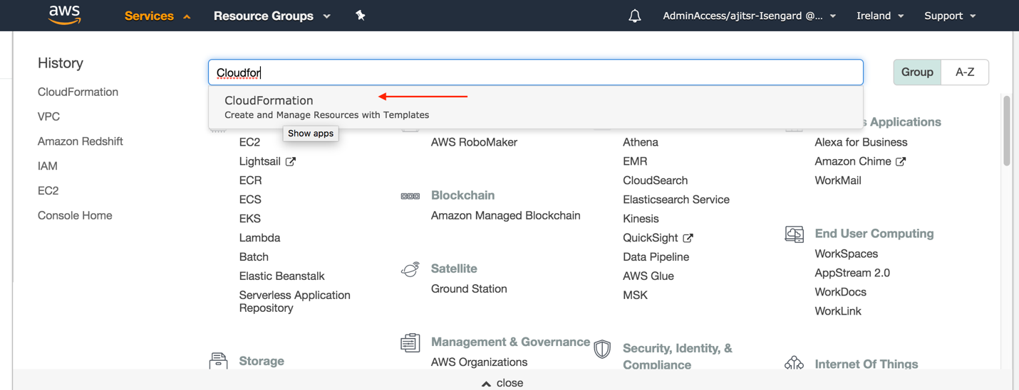

1. Choose “stack” from left hand side quick menu and click on “create stack”:

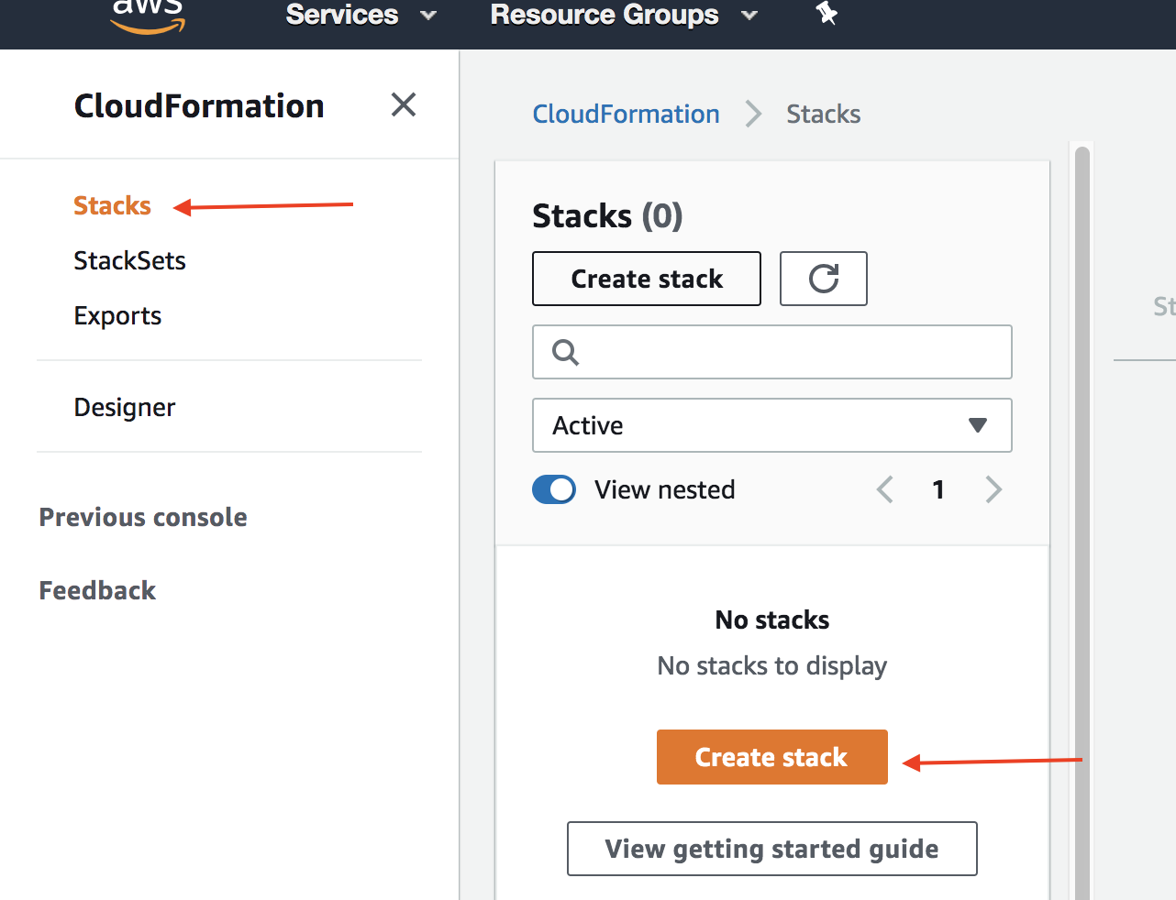

1. Next, select “Upload a template file” and upload the “Redshift-Foundation-CF-Template.json” file. Name the stack as “RedshiftLab-Foundation” on the next screen and proceed to create the stack.

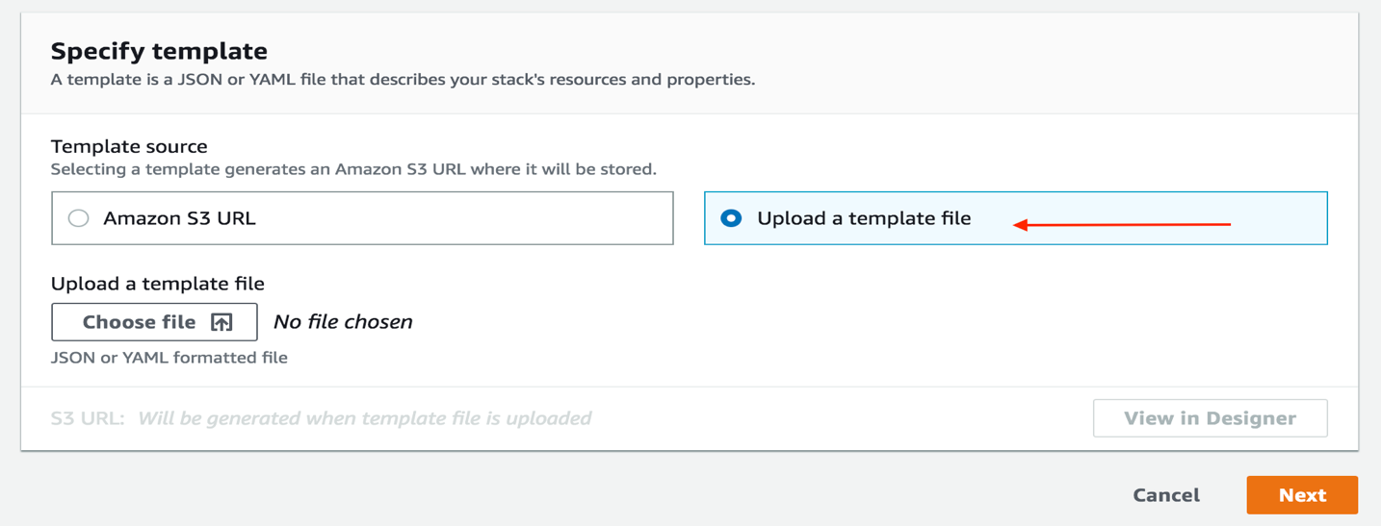

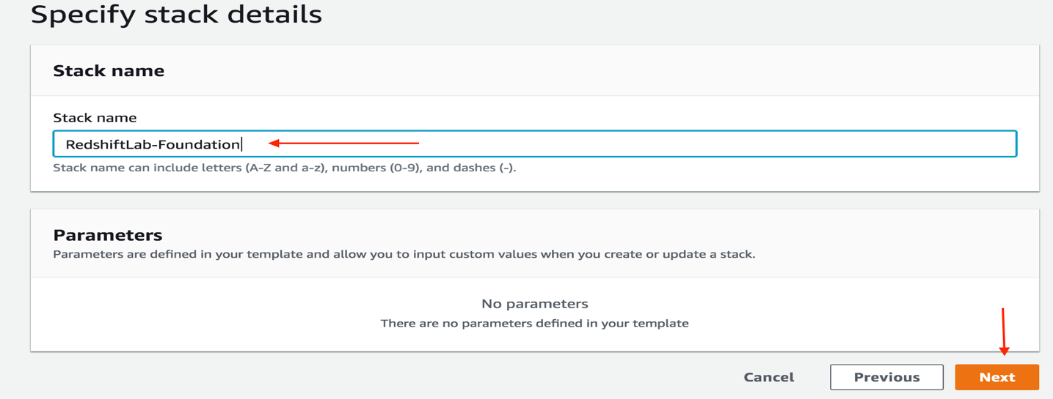

1. Wait for the stack to finish creating the resources.
2. Next, choose IAM from the services drop down menu and select roles from left side menu bar.

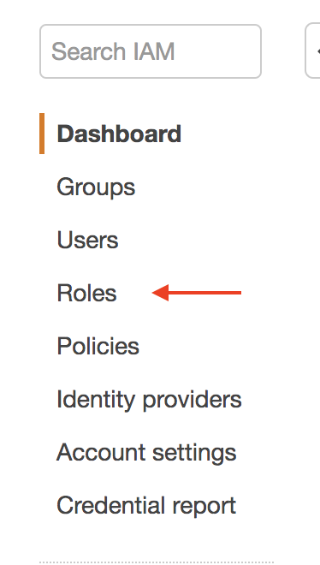

1. Next, click on “create role”. Choose the role type as “AWS Service” and select “Redshift Customizable” as the AWS Service.

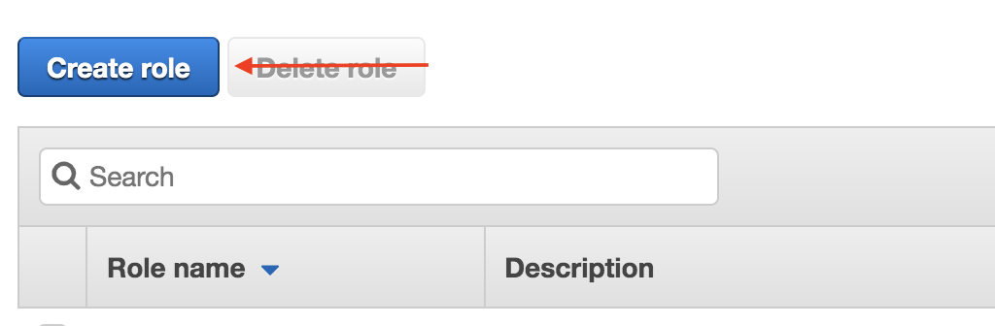

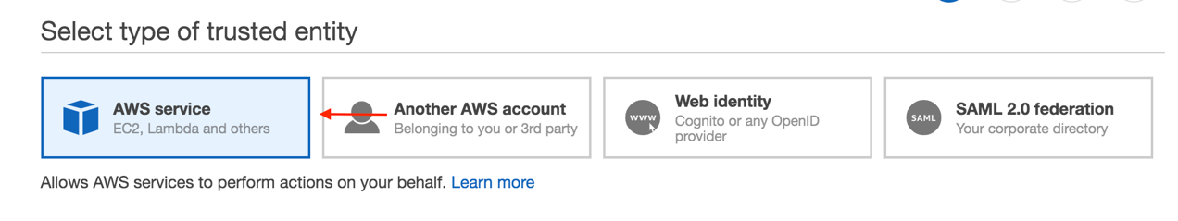

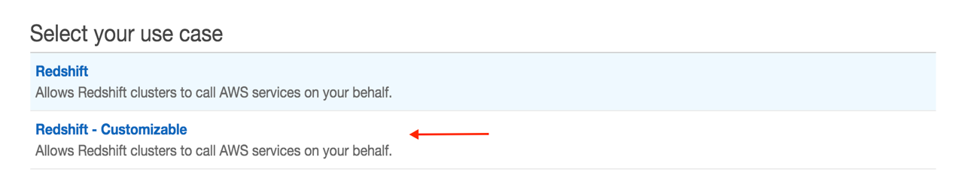

1. Attach “S3ReadOnlyAccess” policy to the role.

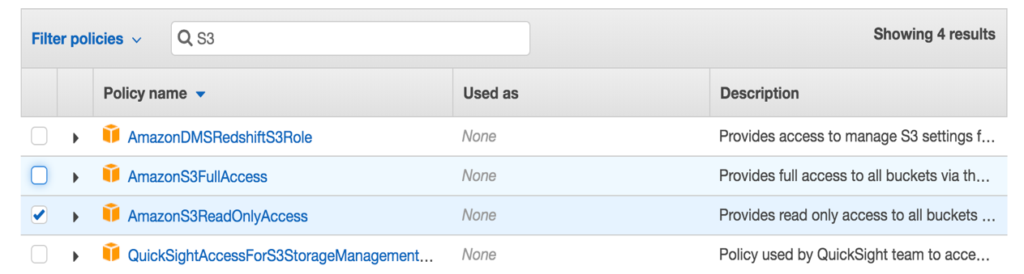

1. Name the policy as “Redshift-Role” and complete the policy creation.

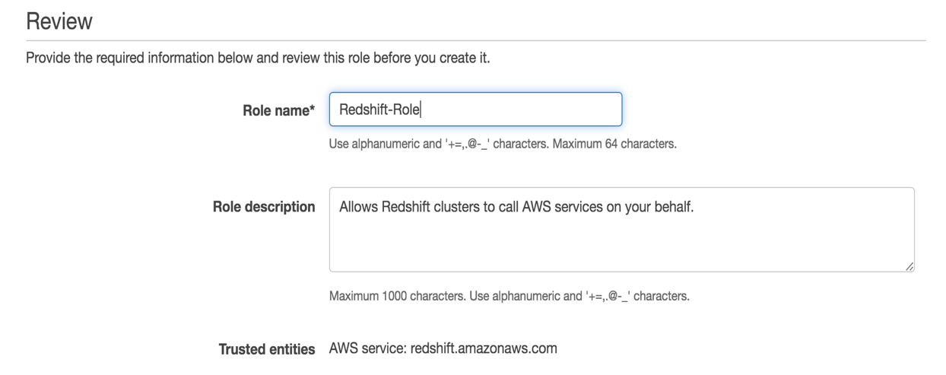

**Part 2:**

The labs use two clients: SQL workbench and PGWeb. Each participant must setup their own Windows instance pre-installed with SQL Workbench.

LAB1: PG Web client:

PG web client is installed on an EC2 instance, which the participants can access. Please access the client using the URL: <http://99.80.114.166/>

LAB2: SQL WorkBench:

Participants must create a windows instance using the privately shared AMI to gain access to SQL workbench client. Follow the instructions below to create the SQL workbench client instance:

1. Choose EC2 from the service drop down menu.
2. From the left side menu, click on AMI and toggle to “Private Images”/

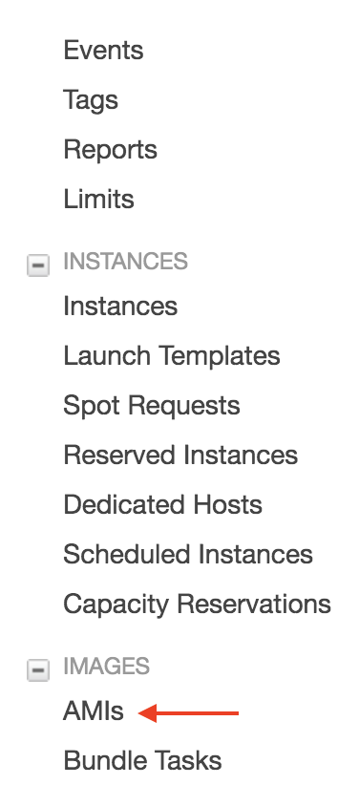

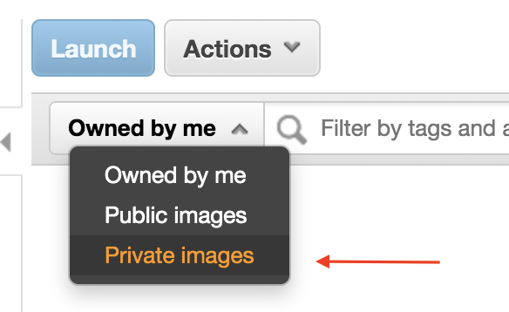

1. Choose the “WindowsWorkBenchInstance” image and click on the “Launch” radio button.
2. Proceed to create the instance with following parameters:
   * Instance type – t3.medium
   * VPC – ImmersionDay-VPC
   * Subnet – Public-ImmersionVPC
   * Auto-assign public IP – Enable
   * Storage – EBS (30GB)
   * Security group – RedshiftLAB-SG
   * Key pair – “Proceed without key pair”
   * Tags – “Name” – “<yourusername>-SQLWorkBenchInstance”
3. You can use the “Download Remote Desktop” client application from the connect window tab when the instance creation is complete. For MacOS users you can install “Microsoft Remote Desktop” client from the app store.

Please proceed to QwikLabs for the remainder of the instructions.

LAB 1 – [**https://bit.ly/2C5G0GG**](https://bit.ly/2C5G0GG)

LAB 2 – [**https://bit.ly/2EgCJWx**](https://bit.ly/2EgCJWx)

Please name the Redshift instances as “<yourusername>-lab” to distinguish from other participants.